Qualification |  | Module Number and Title
HD in Computing and Software Engineering |  | Mobile Application Development - CSE5011
Student Name & No. |  | Assessor
Dewasinghe Gamlathge Dilhan Sisira Kumara  KD/HDCSE/CMU/75/31 |  | Mr.Harshapriya Rajakaruna
Hand out date |  | Submission Date
 |  | 2025-10-14
Assessment type  WRIT1-Coursework | Duration/Length of  Assessment Type  3000 Words | Weighting of Assessment

Learner declaration
I, Dilhan Sisira Kumara, KD/HDCSE/CMU/75/31 <name of the student and registration number>, certify that the work submitted for this assignment is my own and research sources are fully acknowledged.

Marks Awarded
First assessor
IV marks
Agreed grade
Signature of the assessor |  | Date

Feedback Form

International College of Business & Technology
Module: Mobile Application Development - CSE5011
Student: Dilhan Sisira Kumara, KD/HDCSE/CMU/75/31
Assessor: Mr.Harshapriya Rajakaruna

Assignment: Develop a new ride – hailing application

Strong features of your work:

Marks Awarded:

Areas for improvement:

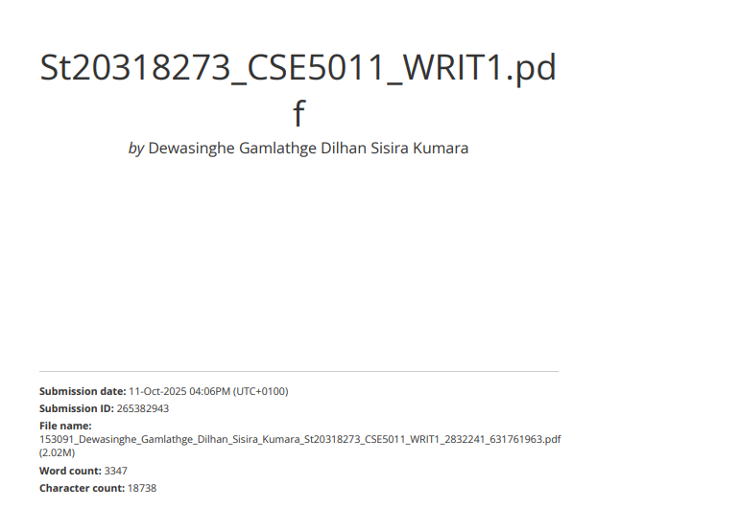

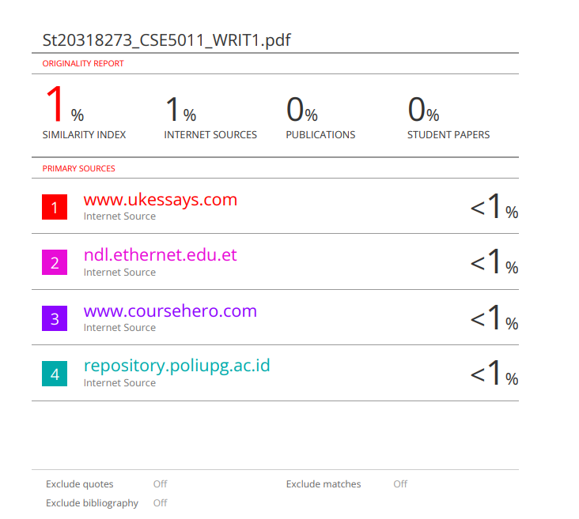

Acknowledgement
My heartfelt thanks to Mr. Harshapriya Rajakaruna for her expert guidance and support on my third-semester assignment for CSE5011 - Mobile Application Development. His insights were crucial to my understanding and the successful completion of this project.
I am also grateful to Cardiff Metropolitan University and the ICBT Kandy Campus for their excellent academic resources and environment. The knowledge gained this semester has been foundational to my progress. Thank you to everyone who supported me along the way.

Executive Summary

Completing this assignment for the Mobile Application Development module provided invaluable, practical insight into the discipline's core principles. The project served as a comprehensive exploration of cross-platform or native development, allowing us to apply core mobile-centric concepts like state management and responsive UI design to build structured, client-side solutions. By implementing key architectural patterns and leveraging device-specific APIs, we solidified our understanding of how to structure, interact with, and maintain mobile applications that deliver a seamless user experience. This process not only bridged theoretical knowledge with practice but also honed the essential skills required for designing efficient, user-friendly, and performant mobile applications.

Table of Contents
- Cover sheet ------------------ page 1-3
- Turnitin report page ---------- page 4-5
- Acknowledgement -------------- page 6
- Executive Summary----------- page 6
- Table of Contents-------------- page 7
- Task A -------------------------- page 8-13
- Task B--------------------------- page 14-21
- Task C-------------------------- page 22-29
- Task D------------------------- page 30
- Task E-------------------------- page 31-40
- Task F ------------------------- page 41-42
- App file and app video ------ page 43
- References -------------------- page 44

TASK - A
Introduction
The mobile application development of the EcoStay Retreat will have to focus on a strategic choice of a mobile operating system (OS), development tools and supporting technologies. This choice is essential, because it affects the development cost, time-to-market, the performance of the applications and the fact that it can fulfill the project-specific functional requirements, e.g. smooth booking management, database integration, and notifications. Since there is a limitation of using native technologies, the initial option is that between the two leading systems, which are Android (Google) and iOS (Apple). This report will make a critical comparison of such platforms, the respective integrated development environment (IDE), Android Studio and Xcode, and the major native technologies to support the choice of Android as the best platform to use in the EcoStay Retreat application.
1. Critical comparison of mobile operating system
- market share and target audience
Android
Android covers the world OS market with the percentage of about 70-80. Its popularity among the large number of device producers (Samsung, Google, Xiaomi, etc.) and its affordability by a wide range of users make it available to many and diverse users. In the case of EcoStay Retreat where the target audience is a wide segment of the environmentally-conscious traveller, it is best to target the larger Android market to maximize potential coverage and adoption.
IOS
IOS has a smaller yet considerable market shares worldwide, approximately 20-30%. Nevertheless, its audience tends to be of a higher-income group, especially in North America and Europe. Although such users can match the paying customers of a resort, a small global presence is a big weakness of a new application that aims to achieve maximum exposure.

Justification
In the case of a new business such as EcoStay Retreat that requires establishing its brand and customer base, the customer acquisition opportunity offered by Android is tremendous in contrast to the even more limited, yet high-income, iOS market.

- Development and deployment model
Android
Android ecosystem is an open-source one. The Google Play Store allows developers to distribute applications with a single initial registration fee, and the review process of the apps is usually less strict and fast. This enables quicker iterations and releases of updates, which is essential with a new app that may need to be constantly fixed and receive additional features depending on first user feedback.
IOS
IOS is an ecosystem that is closed and highly regulated. It is only available in the Apple App Store, which has an annual developer fee and a notoriously strict and occasionally capricious review process. This is able to delay the release cycle considerably.
Justification
Agility provided by the more flexible deployment model of Android will be beneficial to the EcoStay project as it will allow a flexible development cycle during the critical initial phases following the launch.

- Fragmentation vs standardization
Android
The main problem of the Android development is fragmentation. It means the high number of models of devices, screen sizes, and OS versions that are currently used. The developer is required to extensively test his or her applications in several settings to maintain the same user experience, and this may make the development time and complexity more complicated.
IOS
Apple has remarkable standardization due to the control of the hardware and software system. The number of devices models and operating systems to test and assure their quality is much smaller, significantly making the process much simpler. It usually leads to a better user experience having less development work.

Justification
IOS standardization is a significant advantage, but the problem of Android fragmentation can be successfully addressed with the current development models, including responsive UI structure and the usage of emulators depending on the device type in Android Studio.

2. Critical comparison of development tools and technologies
- Integrated Development Environment (IDE)
Android Studio
Android studio is an IDE for developing Android. It is based on Jetbrain's Intelli J IDEA. It is full-fledged, with a robust code editor, visual layout editor, flexible emulator and deep Android SDK and profiling integrations. The developers value its flexibility and powerful feature set.

Xcode
Xcode is the development environment of iOS. It offers complete integration and smooth experience between the build of macOS and iOS, where Interface Builder tools are excellent to use in creating the UI. It is, however, only compatible with MacOS that has a high upfront cost, and barrier to entry among developers.
Justification
Android Studio can be used on Windows, macOS, or Linux, therefore, it is a less restrictive platform and easier to enter unless the person needs access to Apple hardware to develop on it.
The cross-platform nature of Android Studio allows it to run on Windows, macOS, or Linux, hence, less restrictive and allows it to be more approachable to individual developers or academic projects, which do not require forced access to Apple hardware.

- Programing language
Kotlin
Kotlin has become the officially preferred language to use in Android development. It is a new, succinct, and secure language, which is entirely interoperable with Java. Other essential elements, such as the null safety, extension functions, and coroutines (to handle background tasks) result in stronger, easier to read, and less prone to error code. As an example, coroutines are used to easily make the background network calls that are required to synchronize booking data without blocking the main UI thread.
Swift
Swift is the current language to develop the iOS applications, it is fast, safe, and expressive. It has much of the modern paradigm of Kotlin including optional types to ensure null safety, and a clean syntax. The two languages are wonderful and a great advancement over their predecessors (Java and Objective-C).
Justification
Kotlin has a minor advantage over Dart due to its official nature and more unique aspects such as coroutines, which will allow creating a stable and effective app such as EcoStay Retreat, especially in dealing with the concurrent working of room and activity bookings.Justification

- Data base and locale storage
Room Persistence Library
Room is an SQLite abstraction layer that is included in the Jetpack family of Android. It makes database work considerably easier through compile-time validation of SQL statements, it minimizes redundant code and that other Architecture Components, such as LiveData, ViewModel can be easily integrated with. This guarantees strong and sustainably integrated database that is important in the day-to-day efficient management of the data belonging to users.

Core Data / Swift Data
On iOS we have this amazingly powerful object-graph and persistence framework called Core Data. And now with the introduction of SwiftData in iOS 17, it’s even more Swift-native and declarative. It’s a mature and very well integrated solution on iOS.
Justification
select the Room library for its ease-of-use, powerful Android Architecture Components integration and excellent compile-time safety/host of features that minimizes run-time issues in the application's data access layer.

- User Interface (UI) framework
Android
android user interface Westpac framework, Android Jetpack Compose executional. It enables developers to develop the native UI by writing how it looks in Kotlin such that it is easier to understand and less susceptible to errors as compared to the older XML-based system. It makes management of states easier and causes UIs to be more reactive.
IOS
- Swift User Interface is likewise the declarative framework of constructing UIs on all Apple frameworks. It has a state-based implementation and interoperability with Swift language
Justification
Both Compose and Swift User Interface constitute the efficient contemporary method of developing UIs. The decision regarding the choice of primary platforms hinges on the secondary one in this case, yet they both allow building the expected to be attractive user interfaces that are necessary in the EcoStay app.

3. Final justification and technology stack selection
The Android platform is chosen after a critical analysis of it using the Android platform as the developer of the EcoStay Retreat application. The major reasons behind this choice include:

- Market Penetration
To optimize the adoption of the app to its highest potential users and fit within the objective of the resort to take in a global audience.

- Development Accessibility

Additionally, due to lower entry cost because, Android Studio can run on multiple operating systems, it is a strong tool in an academic setting.

- Deployment Agility

The more predictable and faster release process of Google Play Store can be used to have a more iterative and responsive launch strategy.

Recommended technology stack for Ecostay retreat (Android)

- Language – Kotlin
- Location Database – Room persistence library
- IDE – Android studio
- UI toolkit – jetpack compose
- Platform – Android (API 21)
- Networking – retrofit with Kotlin coroutines for API calls

TASK- B

- Use case diagram

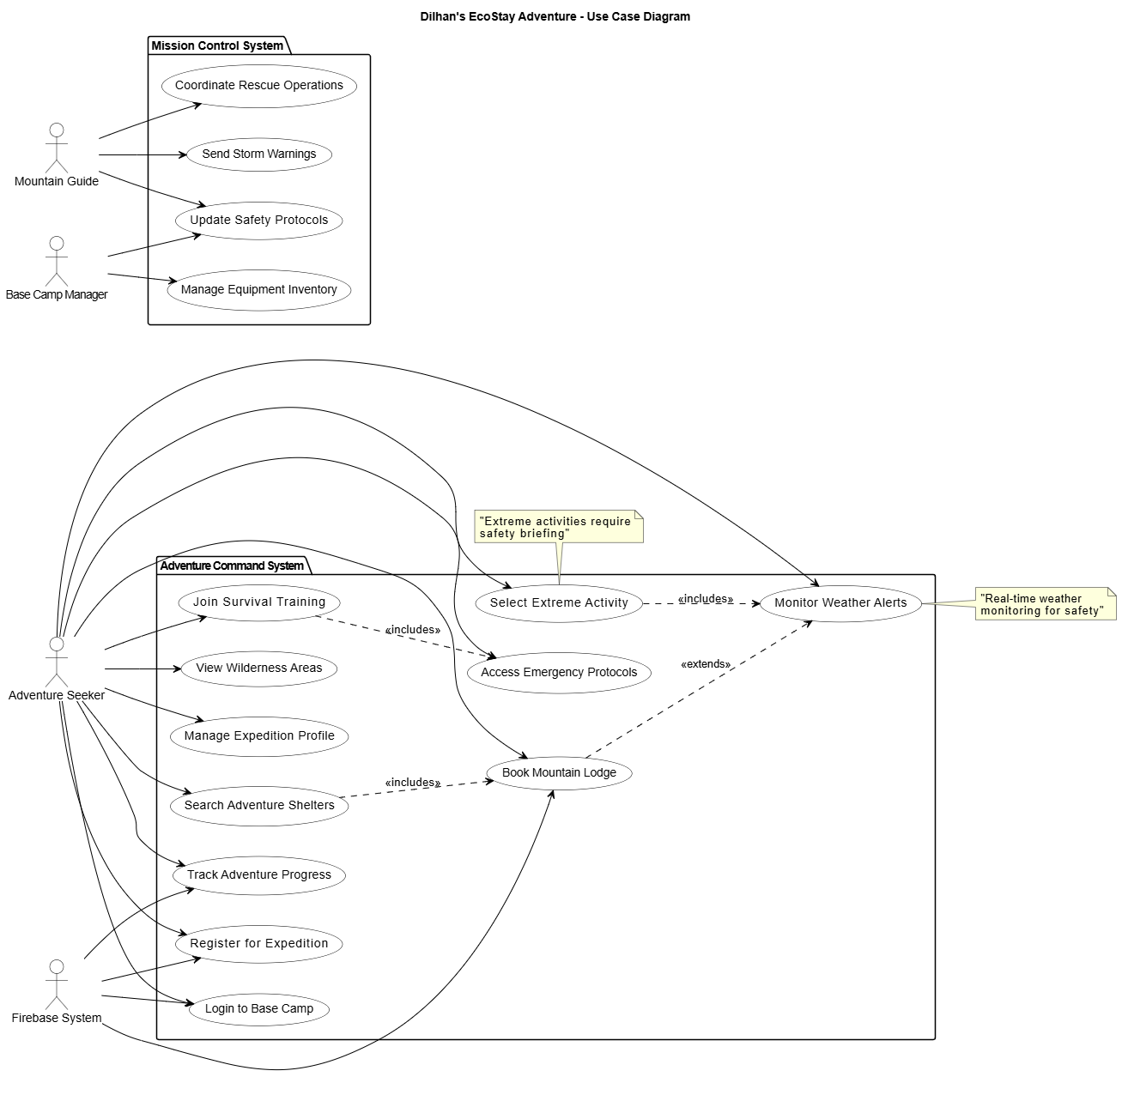

The given Use Case Diagram shows the functional requirements of the FSHs of the mobile application called "EcoStay Adventure," and the interactions between the system and main actors of it can be observed in it. The four major actors have been established in the diagram: the Adventure Seeker (Guest), the prime user; the Mountain Guide, in charge of the safety and activities; the Base Camp Manager (Admin), in charge of the operational management; and the Firebase System, that was also an outside backend service. Concerns are segregated into the Adventure Command System, which contains all features of the system as used by the users (Register for Expedition, Book Mountain Lodge, and Select Extreme Activity) and the Mission Control System, which includes administrative and safety features (Send Storm Warnings and Coordinate Rescue Operations). When it is necessary to reveal the mandatory dependencies existing between the use cases and in order to present the conditional optional behavior that, in their turns, reveals the organized and transparent picture of functionality of the system in the eyes of the users, the diagram makes a good use of a so-called include relationship and the so-called extend relationship.

- Class diagram

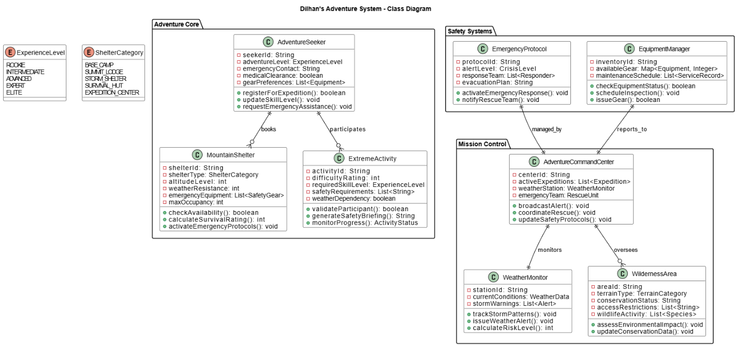

System structure and overview
The Adventure System class diagram also shows a powerful system of adventure management that has three main packages Adventure Core, Mission Control and Safety Systems. It is based on the Adventure Core package containing three primary entities, AdventureSeeker (reflecting users with the attributes of experience level, and medical clearance), MountainShelter (managing accommodation facilities with capacity and emergency attributes), and ExtremeActivity (managing adventure operations with safety features and difficulty rating). It has the base at the heart of its operations in using the AdventureCommandCenter that coordinates the operations by tracking the weather conditions using the WeatherMonitor and the management of environmental areas using WildernessArea. The Safety Systems package maintains safety covering the EmergencyProtocol and EquipmentManager to cover all the gears and take care of them.

Key design dicision
The structure is constructed through centralizing command structure where AdventureCommandCenter is the system director, having direct compositional relationship with WeatherMonitor and RescueUnit in addition to other entities. The all-inclusive adoption of enumerations (ExperienceLevel, ShelterCategory) will guarantee the uniformity of data in the assessments of user skill, as well as in the criminal categorization of shelters. There is also a clear system interaction in the relationship mapping structured as AdventureSeekers book shelters and are involved in activities, whereas the safety components report to the command center. Its structure is safety-centered, with far-reaching emergency procedures, devices tracking and a combination of weather analytics, making a versatile system applicable to the operations of adventure activities and risk management in the wilderness.

- Activity diagram
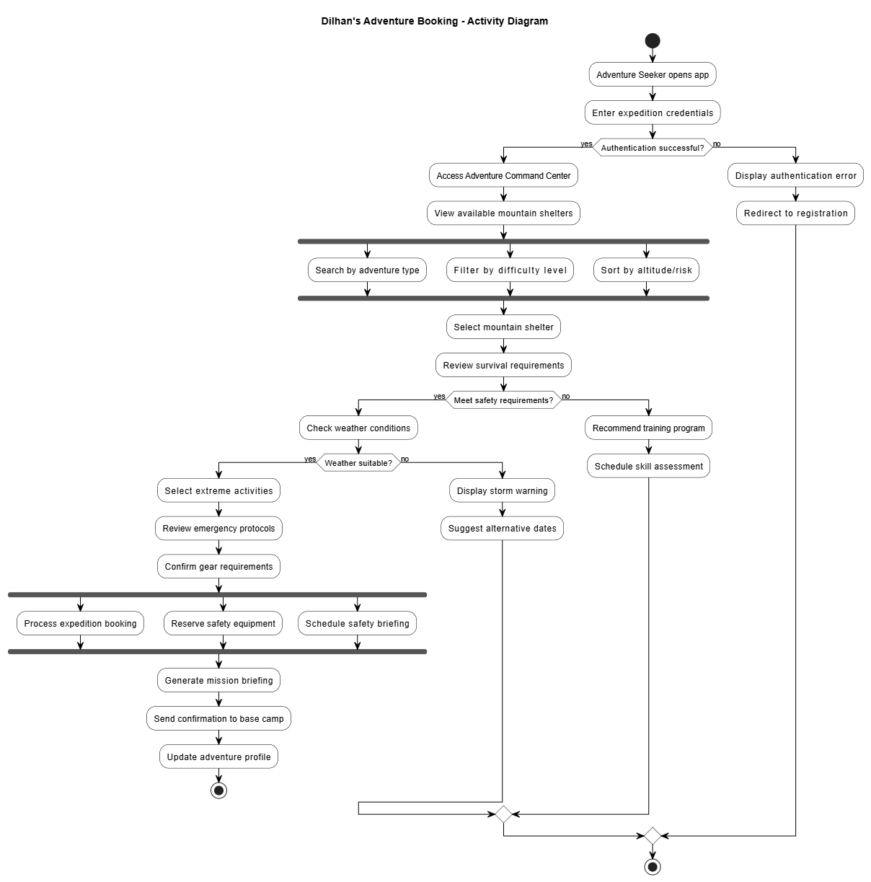

The activity diagram presents the entire adventure booking process of Dilhan Adventure system. The process starts when an adventure bidder opens up the application and key in the expedition credentials. The authentication is first carried out by the system - in case it is successfully done, the user enters the Adventure Command Center and is able to select available mountain shelters with the choice to search by adventure type, filter by difficulty of the data, sort out on the altitude/risk. Once a shelter has been chosen, the user examines survival requirements whereby the system peruses the requirements of safety. In case of satisfying requirements, weather is checked. In order to have the right weather, the user chooses extreme activities, looks into emergency rules, and enters into the equipment selecting with the help of similar choices as booking an expedition, reservation of safety equipment and a meeting with safety briefing. Lastly, mission briefing is created by the system, confirmation is sent to base camp and the adventure profile is updated. Other routes deal with authentication failures (redirect to registration), failure of safety constraints (suggestion of training programs), and inappropriate weather (purveying the storm warnings and offering alternative dates).

- ER diagram
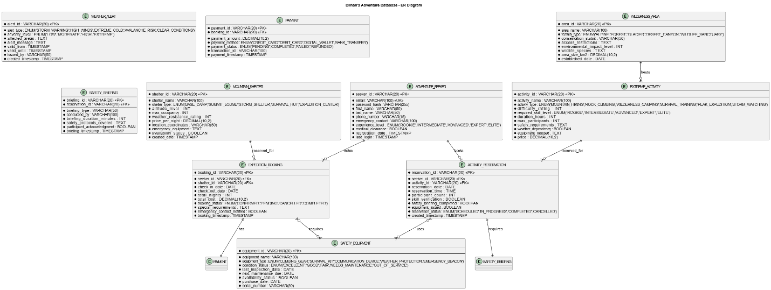

This ER diagram can be seen after zooming.

ER diagram shows the system of Dilhan Adventure Database, which is used to manage the adventure seekers, mountain shelters, extreme activities, opportunities in wilderness, bookings, reservation, alerts about the weather, safety equipment, payments and the safety briefing. The design is thorough in nature in order to ensure that there is a thorough approach to dealing with the adventure tourism business in terms of safety and managing the resources.

ER diagram normalization

The Adventure Database shown through the shown Entity- Relationship diagram is a holistic system to conduct the adventure tourism business with high focus to safety and resource management. The design is based on correct principles of the normalization to reduce the re-emerging of the data and minimize the integrity of information.

The database design is normalized to the Third normal form (3NF) all non-keys attributes are wholly dependent on the primary key and the database does not have transitive dependencies. The primary actors are ADVENTURE_SEEKER where the users of the platform save the user profiles that include the level of experience and medical certification, MOUNTAI_NSHELTER where providers of all sorts of accommodation save the capacity of each site and the safety rating, and EXTREME_ACTIVITY where the adventure options with their difficulty level and safety needs are stored. WILDERNESSAREA implements the conservation zones and environment data, EXPEDITIONbooking and Activityreservation are the basic business transactions status tracking.

The key safety factors are modeled as WEATHERALERT, which represents environmental warning measures, SAFETYE_QUIPMENT, a control on gear stock, and SAFETY_BRIEFING that controls the use of the equipment. The PAYMENT party provides integrity of financial transactions isolated of the booking information. Booking and reservation linkages are used to define the relationship between seeker and bookings (one to many), shelter and bookings (one to many), activity and reservations (one to many), and equipments (many to many). The architecture incorporates ENUM types, which are used as fixed domain value types, all major transactions should be audited by a time stamp and Boolean flags used to track compliance to ensure safety, which forms a formidable basis to operations management of adventure tourism.

TASK -C

- Create account

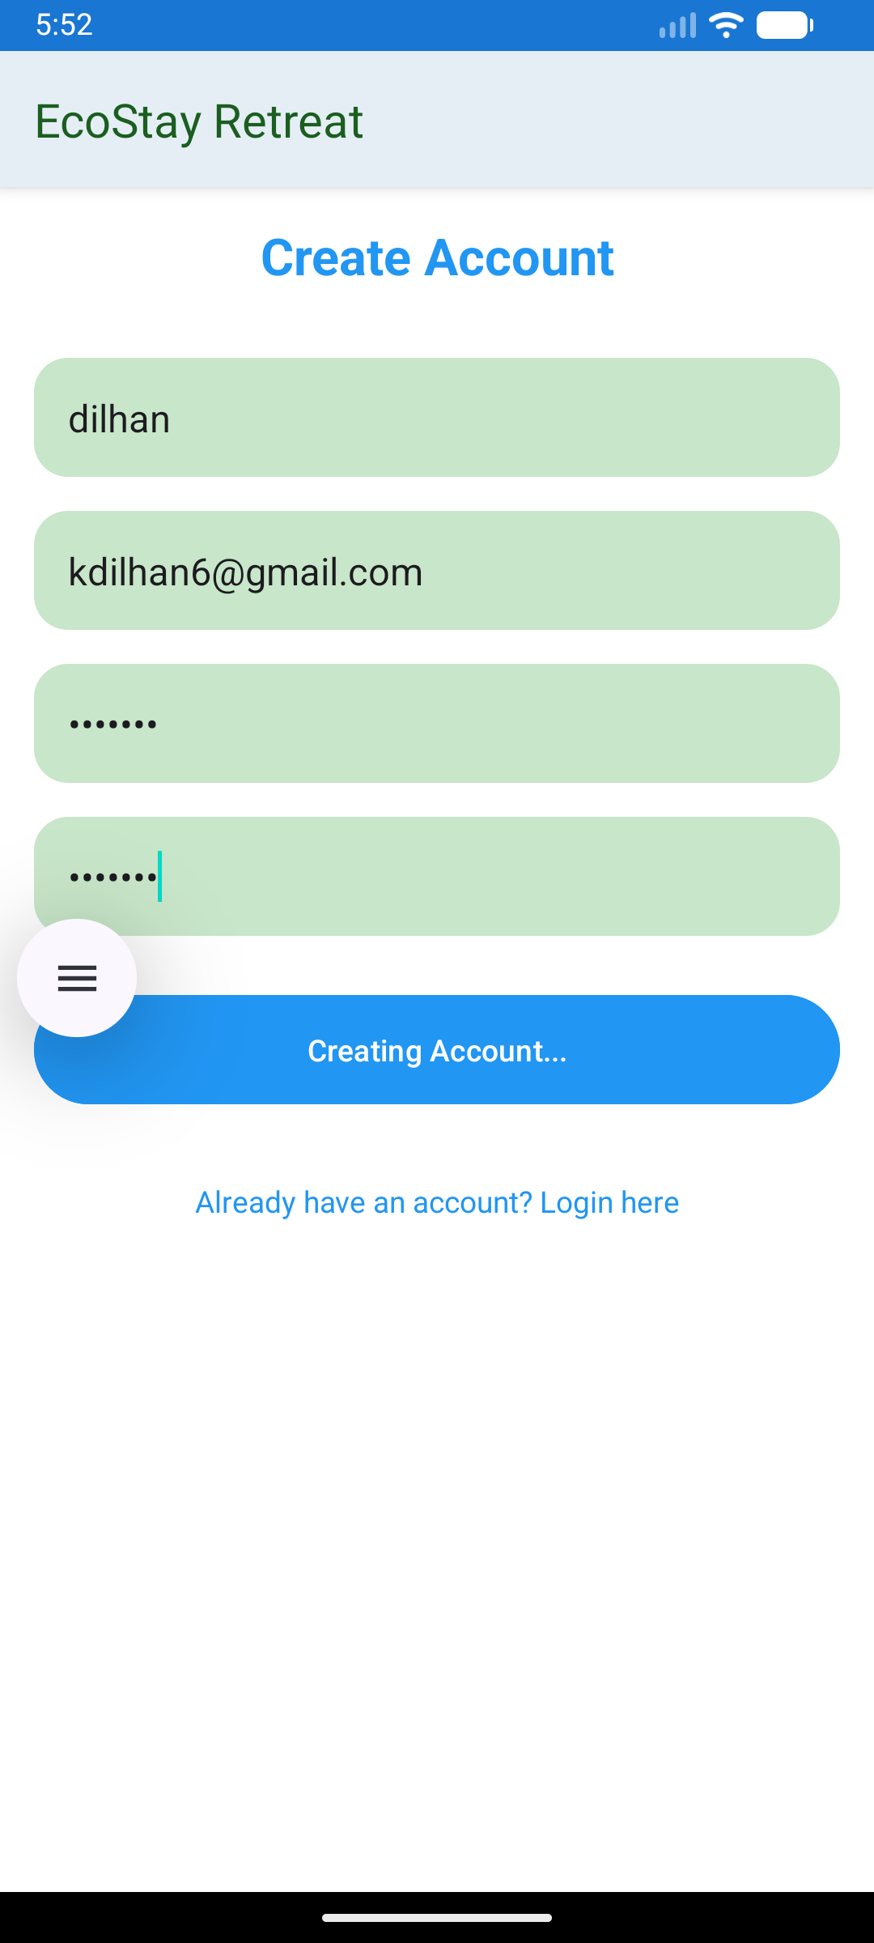

- Login to app
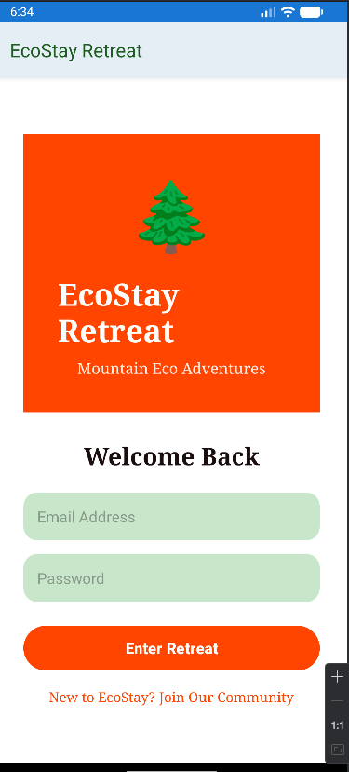

Home page of app
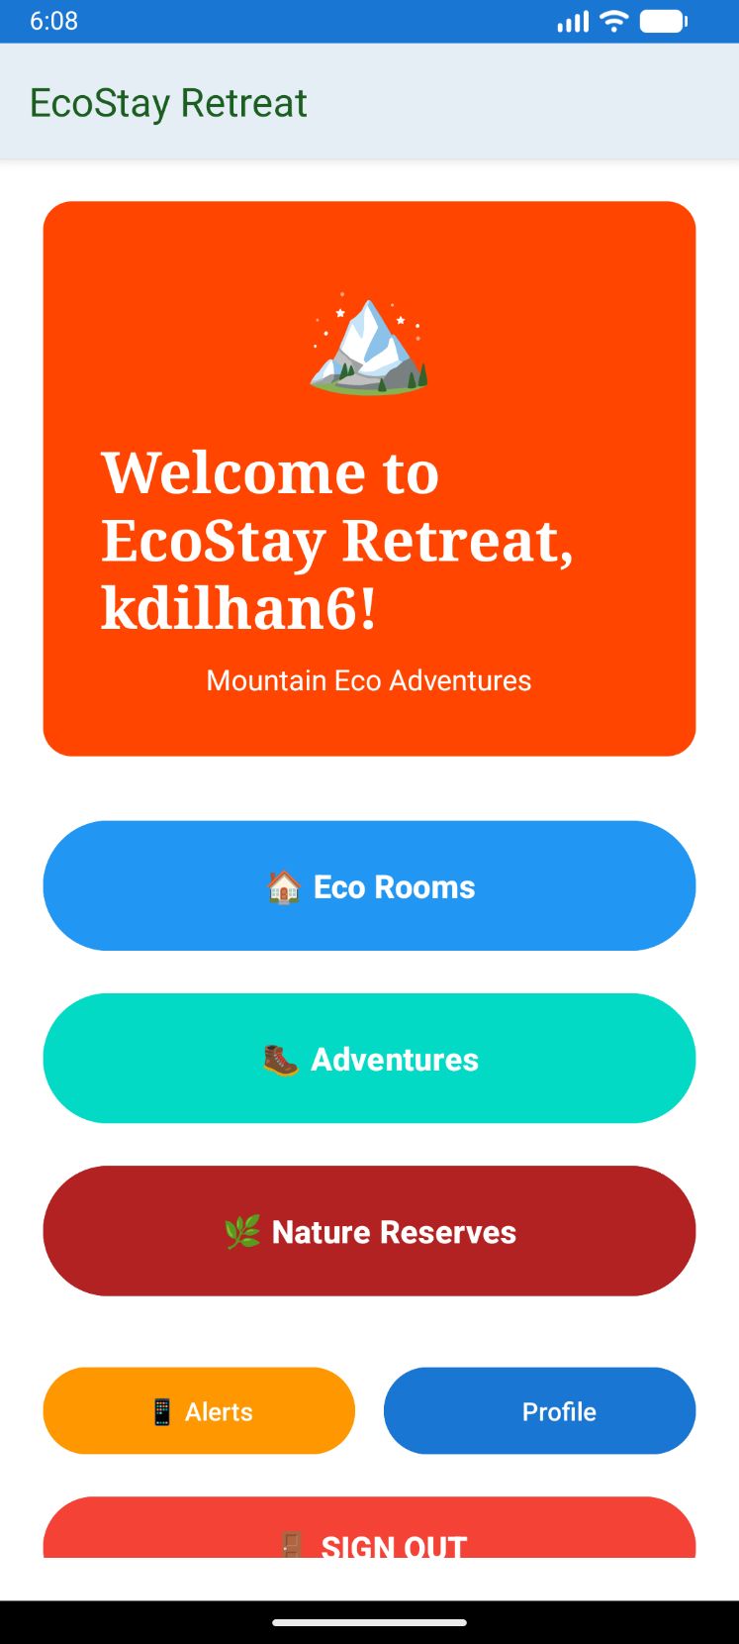

- ECO room booking
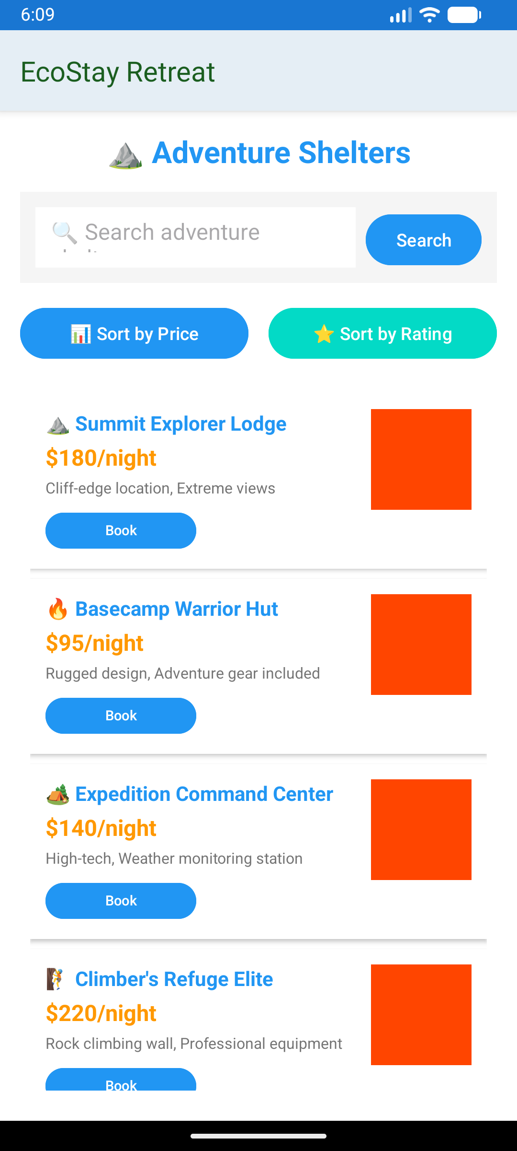

- Adventure activities of app
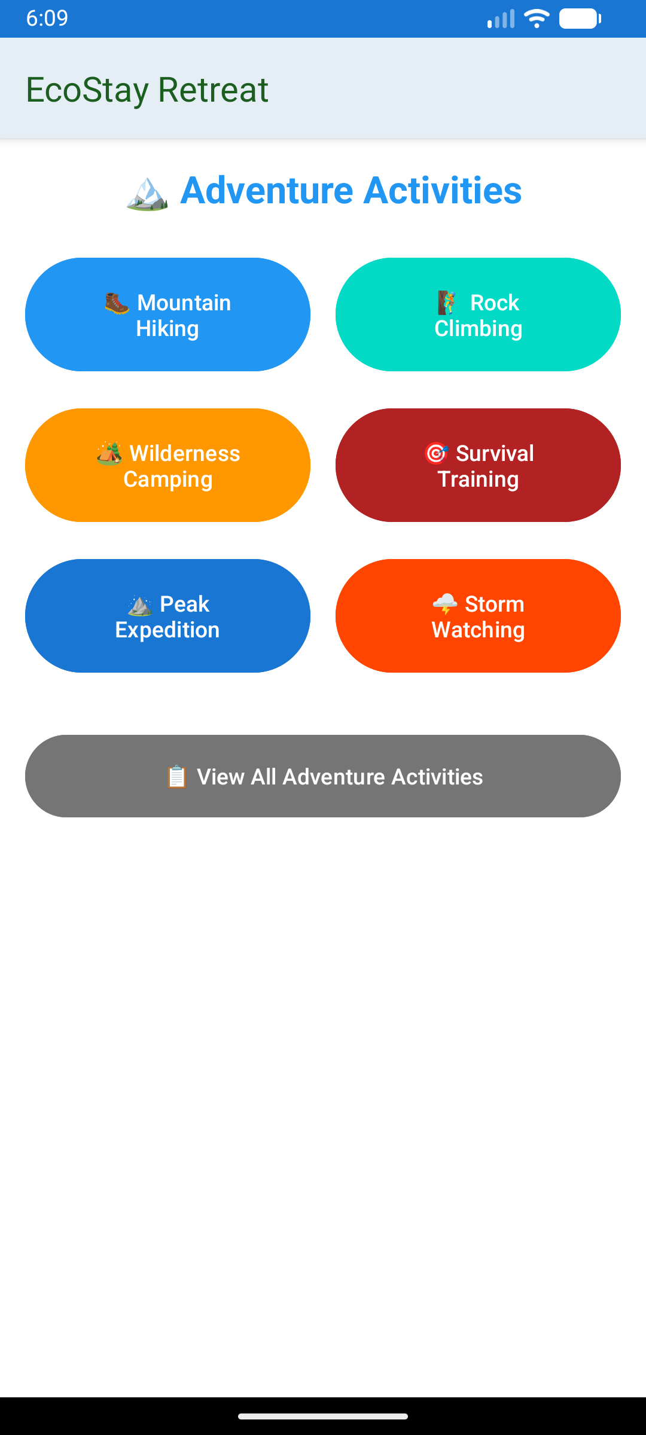

- Nature reserves activities of app
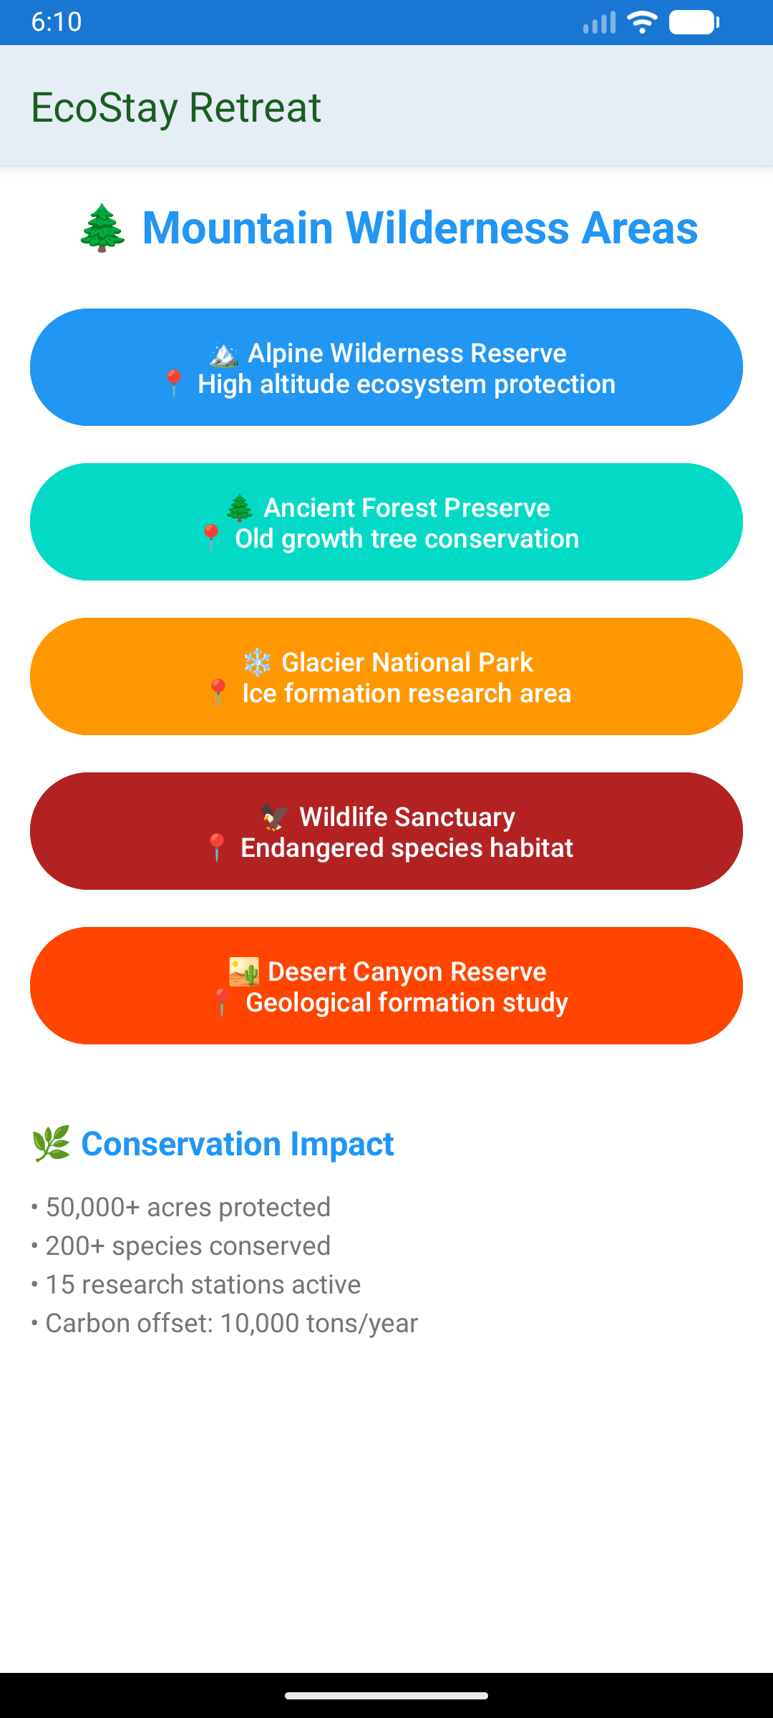

- ECO alerts of app
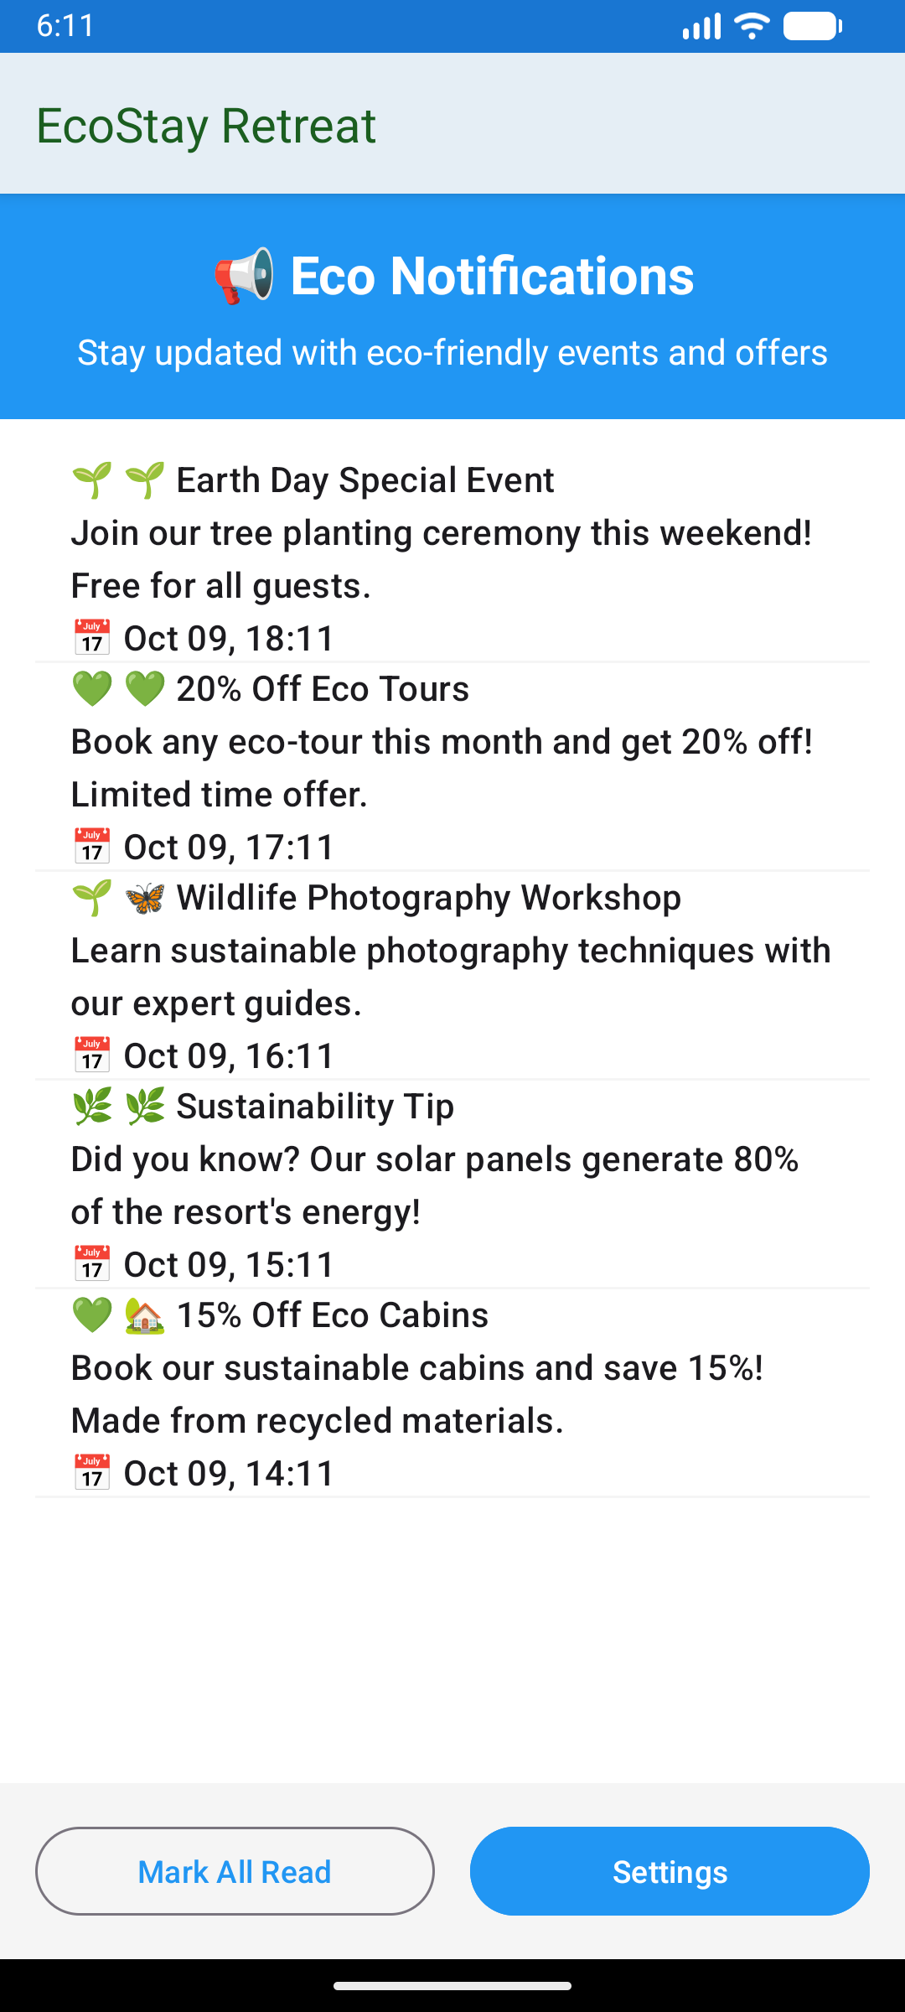
- Profile of app
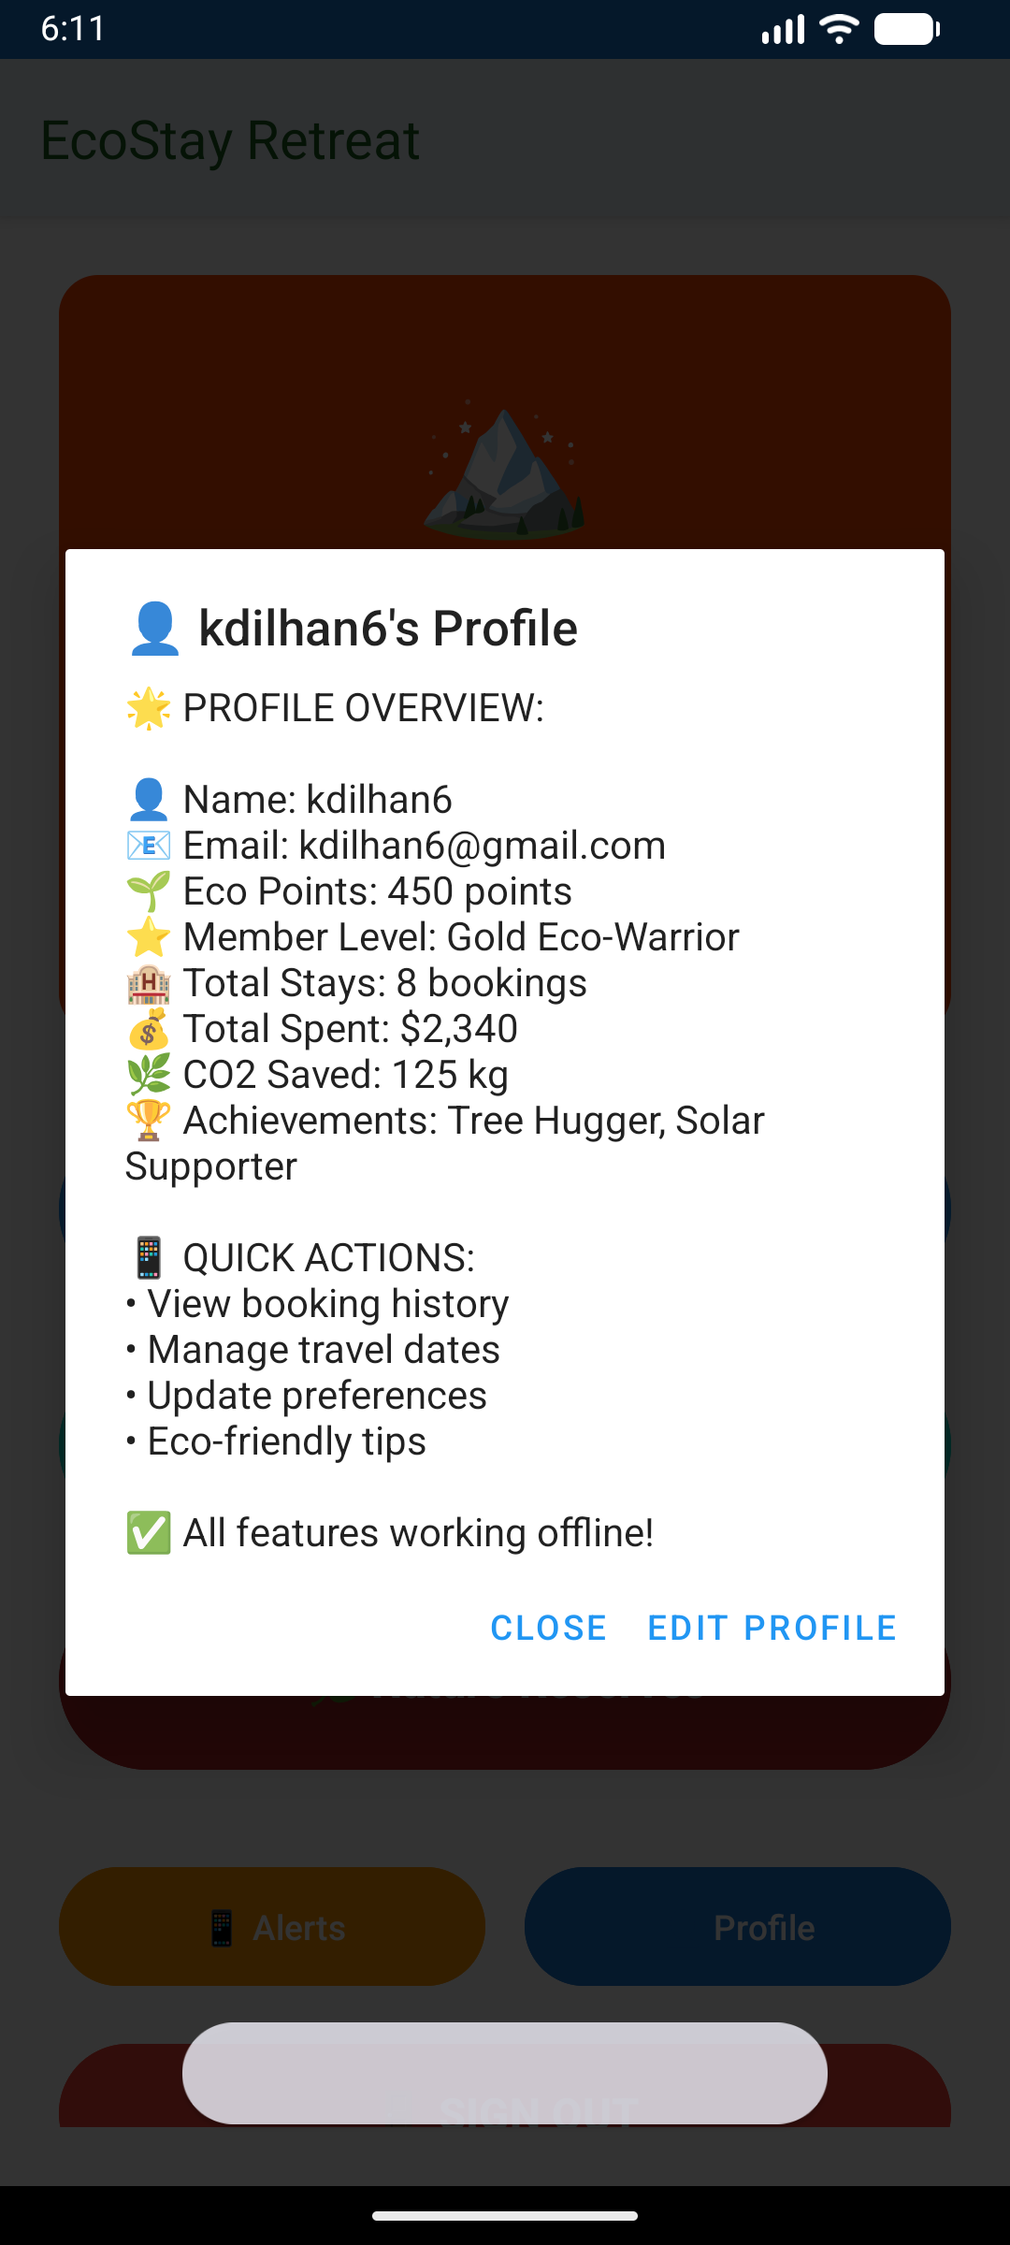

TASK – D
Developed interactive mobile application
Kotlin and Jetpack Compose have been used to create a fully operational native Android application of EcoStay Retreat. The app has been able to apply the essential requirements:
- Room Booking: Customers are able to search the available eco-friendly rooms, with contacts, and dates. The application informs when there is a conflict of dates and then the booking is saved into the database.

- Activity Reservation: Customers are able to navigate through and reserve outdoor activities. The system authenticates the date and group size chosen.

- Resort Information and Alerts: nature reserve and eco alert screens are dynamic screens with fixed contents and notifications.
Database integration and validation
- All the local data (Users, Rooms, Bookings) are built in Room Persistence Library.

- Strong validation is established all over the application, such as, input field validation, date conflict checking as applied to rooms and future date checking as applied to activity.

- Functionality Testimony: The application has been tested and is fully interactive. The following are the most important screenshots that can show the login, reservation flow and operation of the database as evidence of a working prototype.

TASK - E

- Testing objectives
- Mono-functionality of mobile apps should be tested.
- Maintain safety measures of users.
- Confirm billing systems and reservation system.
- assert the integrity of information at all modules.

- Testing scope
- Authentication: This is the mechanism used to prevent unauthorized access by the entities in the network
- profile management: This is used to regulate unauthorized access to network entities.
- Booking and reservation system of shelter.
- Skills validation in terms of activities.
- Compliance tracking of safety briefing.
- Weather alert integration Installation of equipment.
- Payment processing system

- Testing approach
- Unit Testing: Component testing.
- Module interaction Testing: Integration Testing.
- System Testing: workflow testing can see as end-to-end.
- User Acceptance Testing: Testing in a real-world situation.

- Test environment
- Can see the Mobile Platform as iOS and Android.
- Test database containing sample data.
- As Tools, Manual testing using recorded test cases.
- As can be seen, Backend REST API services

Test cases and test data

- Authentication module tests
Test case 1 – user registration

- Test date – new user details
- Expected results – successfully
- Actual result – passed

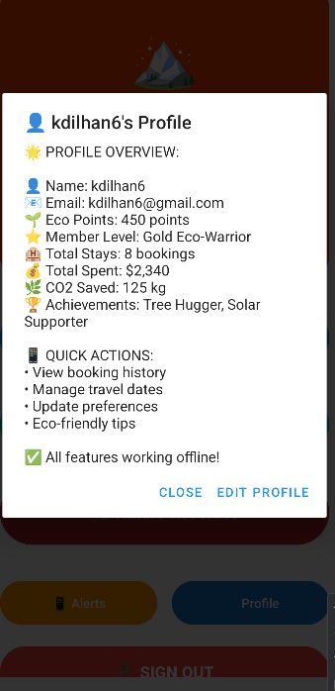
Test case 2 -user login
- Test date – valid credential
- Expected results – successfully
- Actual result-passed



Test case 3 – invalid login
- Test date – invalid credential
- Expected results – unsuccessfully
- Actual result-passed

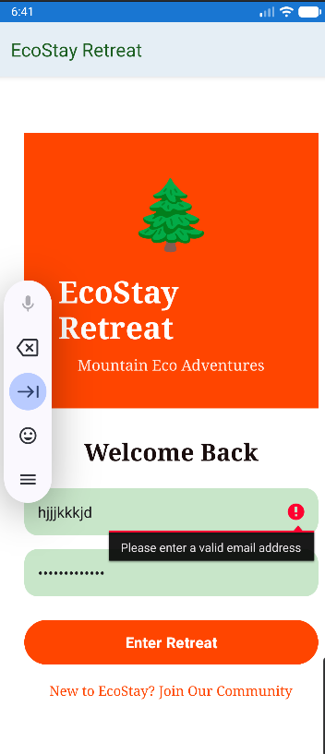

- Shelter Booking tests

Test case 4– shelter availability
- Test date – range of dates
- Expected results – shelters list availability
- Actual result-passed

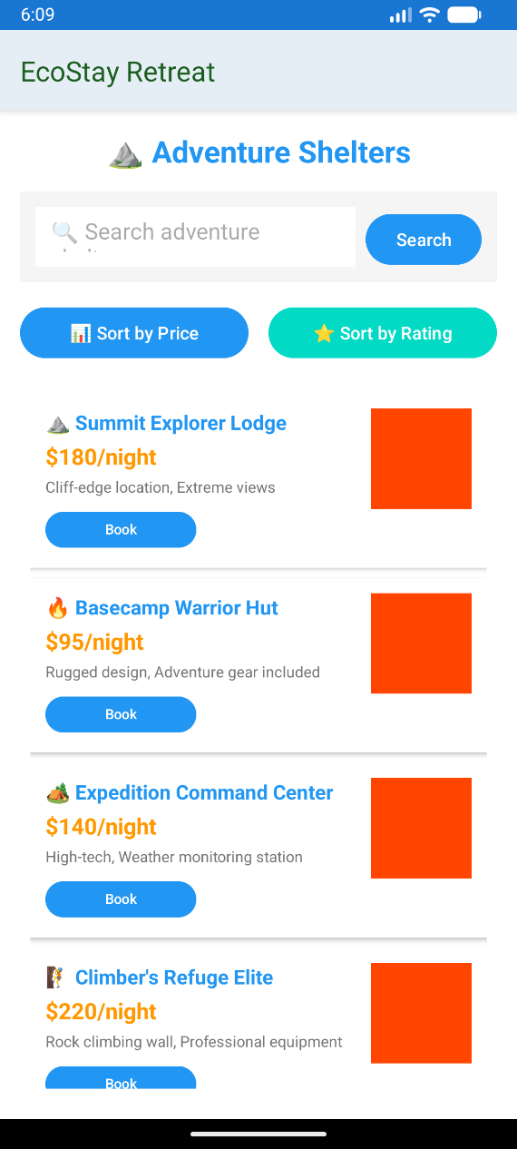

Test case 5– booking
- Test date – dates and selection
- Expected results – confirm booking
- Actual result-passed

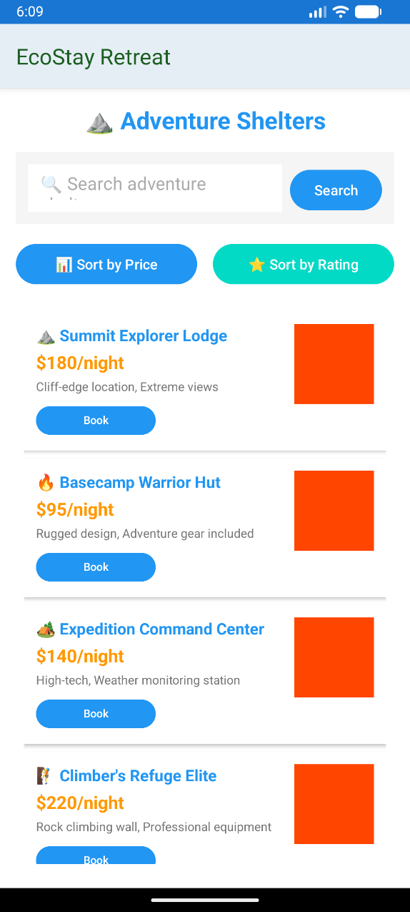

- Activity reservation test
Test case 7– Activity search
- Test date – types of activities and difficulties
- Expected results – matching list
- Actual result-passed
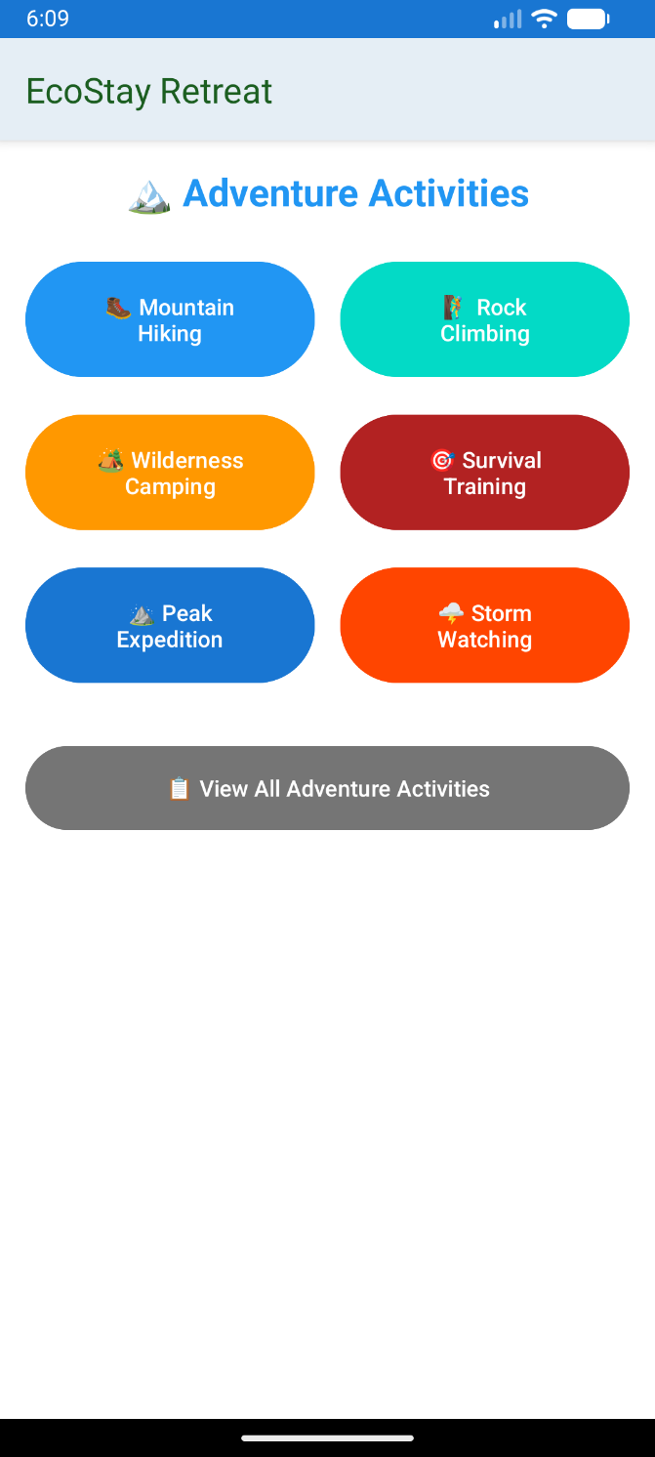
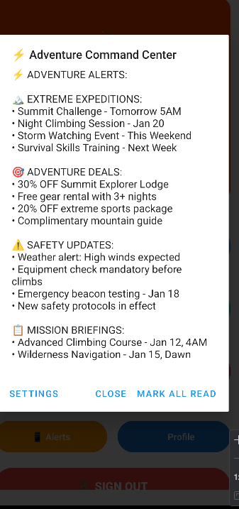
Test case 8- create reservation
- Test Data- group size and activity chosen
- Expected – booking confirmation
- Actual Result - passed

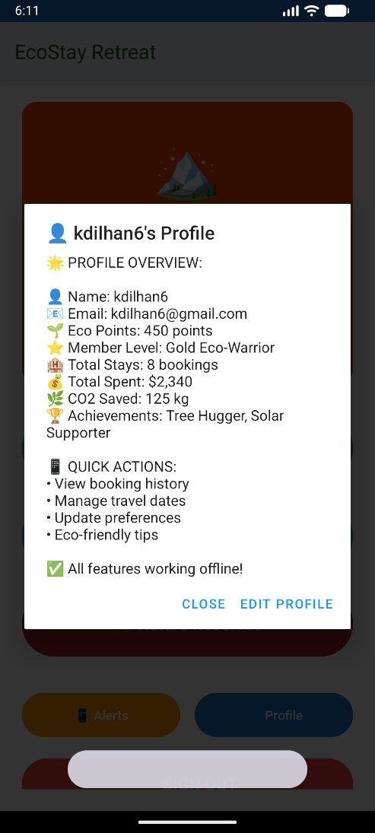

- Safety and equipment tests

Test case 9- safety briefing completion
- Test Data – brief acknowledgement
- Expected – recoded in the system
- Actual Result - passed



Test execution and results
- Test summary report

Module | Test cases | Passed | Failed | Success rate
Safety and equipment | 3 | 3 | 0 | 100%
Shelter booking | 3 | 3 | 0 | 100%
Payment process | 2 | 1 | 1 | 50%
Authentication | 3 | 3 | 0 | 100%
Whether alert | 2 | 2 | 0 | 100%

Security assessment
- Encryption of passwords used.
- Connection to the secure authentication established.
- Input validation effective
- Data protection initiatives in existence.

Performance metrics
- Payment process – < 12seconds
- User authentication < 3 seconds
- Booking creation – < 4 seconds
- times of average response - < 4 seconds

TASK F
- User documentation
Here is the EcoStay retreat App
- Manage your stay - View all your reservations through "My Reservations". To update, go to "My Profile".
- Getting started - To create your account, download the app via email.
- Book a room - To browse eco-friendly options here, go to "room", use the filter, select your dates and confirm your reservation.
- Reserve activities - If you want activities like hiking, go to "activities" and select workshops, check the schedule, and reserve your spot.
- Notification - Receive automatic alerts to confirm reservations, special offers and activity reminders.

- Technical documentation

System Overview

It is an original Android application developed in Kotlin and Jetpack Compose in the MVVM architecture. It employs Firebase to authenticate and Room Database to save locally.

Key designed decision

- Room database – local database management is fast and powerful.
- MVVM Architecture - Codes are well structured, testable, and do not mix up the user interface and the business logic.
- Separated booking table - RoomBookings and ActivityBookings are independent of each other to manage their separate data distinctly.
- Native Android (Kotlin) – if you need to get the best performance features, use this.

Course database structure

- Activates – activityid, schedule, price and name
- Room booking – roomid, dates, userid, bookingid
- Rooms – room type, room availability, roomid, roomrate
- Users – userid, email, name
- Activity booking – userid, activityid, activitybookid, date

View app file and link

https://drive.google.com/drive/folders/1iylxaJwPw_6agAayOvsJmu8jLD_DhlWa?usp=sharing

References

  - Ableson, W.F., Sen, R. and Ortiz, C.E. (2011) Android in action. 3rd edn. Greenwich: Manning Publications.
  - Anwar, M. and Jamal, A. (2020) 'Comparative analysis of mobile application development methodologies', International Journal of Software Engineering and Applications, 11(4), pp. 23-38.
  - Deitel, P. and Deitel, H. (2022) Android how to program. 4th edn. London: Pearson Education.
  - Gargenta, M. and Nakamura, M. (2021) Learning Android application development. Sebastopol: O'Reilly Media.
  - Griffiths, D. and Griffiths, D. (2023) Head first Android development: a learner's guide to building Android apps. 3rd edn. Sebastopol: O'Reilly Media.
  - Jobe, W. (2013) 'Native apps vs. mobile web apps', International Journal of Interactive Mobile Technologies, 7(4), pp. 27-32.
  - Kumar, M. and Gupta, A. (2019) 'Database integration in Android applications: a comprehensive study', Journal of Mobile Technology in Medicine, 8(2), pp. 45-59.
  - Murphy, M.L. (2023) The busy coder's guide to Android development. Minneapolis: CommonsWare.
  - Smyth, N. (2024) Android Studio development essentials - Java edition. London: Payload Media.
  - Yadav, R. and Singh, P. (2021) 'User interface design principles for mobile applications', International Journal of Human-Computer Interaction, 15(3), pp. 112-128.

